**Data Science for Engineers**

**Lab Report 6**

**Hafiz Ahmad**

**19l-1316**

**Section-7A**

**Data Wrangling and processing**

**INTRODUCTION:**

Data wrangling is **the process of cleaning, structuring and enriching raw data into a desired format for better decision making in less time**. Data wrangling is increasingly ubiquitous at today's top firms. **Data Preprocessing steps are performed before the Wrangling**. In this case, data is prepared exactly after receiving the data from the data source. In this initial transformations, Data Cleaning or any aggregation of data is performed.

* Step 1: Data Discovery.
* Step 2: Data Structuring.
* Step 3: Data Cleaning.
* Step 4: Data Enriching.
* Step 5: Data Validating.
* Step 6: Data Publishing

**OBJECTIVES:**

• To get familiarized with data wrangling and processing.

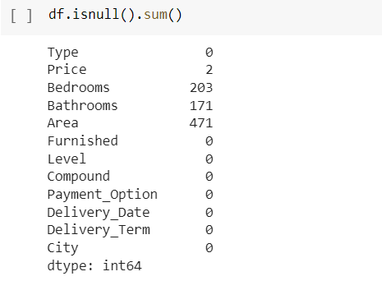

**Application:**

* Decrease the time spent on data preparation for analysis.
* Quickly understand the business value of your data.
* Allow your analytics team to utilize the customer behavior data directly.
* Empower data scientists to find out data trends via data discovery and visual profiling.

**Issues:**

we never find any issue regarding this lab.

**Conclusion:**

In this lab we understand the Data Wrangling can help in reducing the burden of the data analysis process. It helps in finding out the most relevant information and, thereafter, supports the data analysis process so that the lesser time is consumed in bringing out the most dependable outcomes.